LOST CAT
{Insert cat name}
{INSERT} A Good Head & Body Photo of Your Cat
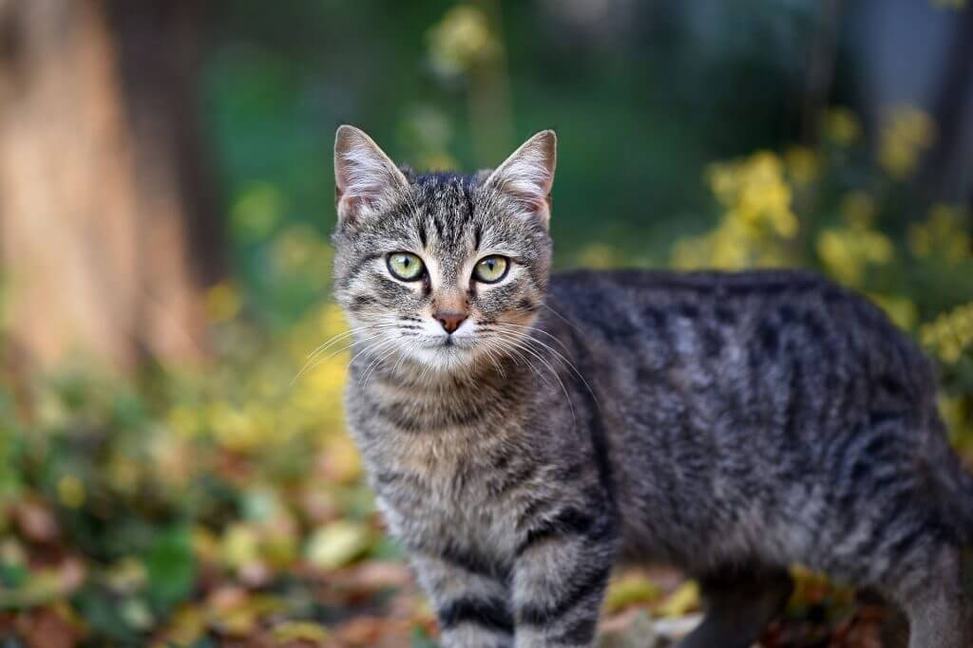
REWARD: €00.00
Identifying marks
Tiger-striped with an orange spot of fur on her back. Friendly and loves tuna. Responds to her name.
Last seen
Corner of Fifth St & Elm, Our City, State - Jan 12th 8:00 a.m.
MAX MUSTERMANN
Tel: 0821 555-1212

