**MISSING CAT**{Your cat’s name}

{Add} A clear full picture of the cat. Here’s an example:

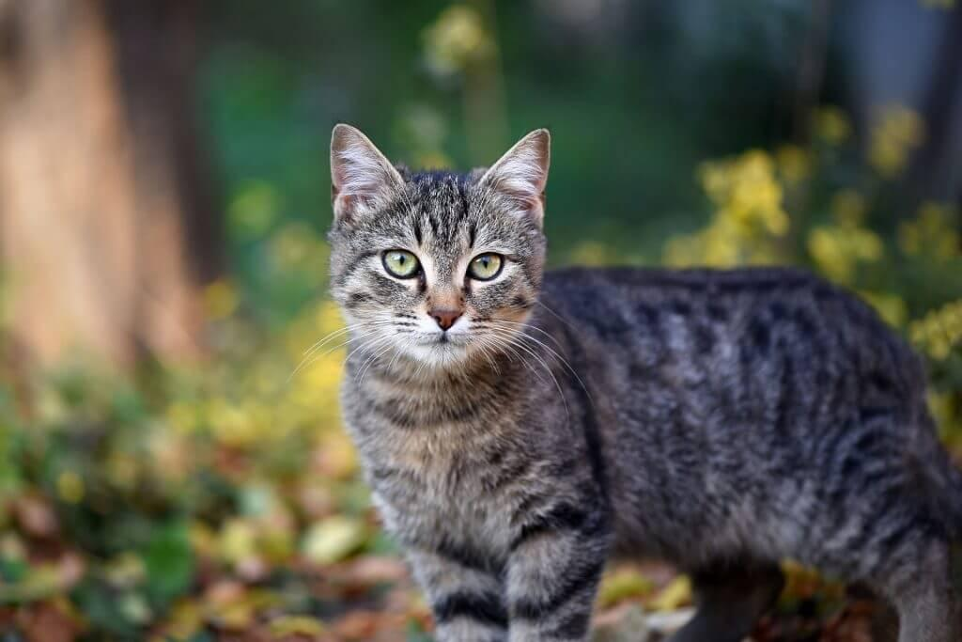

**REWARD: ($)**

**Identifying characteristics (Add your own)**

Tiger stripes with orange spots on the back.

Loves tuna.

Responds to its name.

**Last seen**

**(**At Venice Beach, LA, California, on January 12 at 08.00)

**(Your name)**

**Phone:**